Instructions for Preparing Camera-Ready Manuscripts for the “Tritium2013” Conference (Bold, 12 point, Times or Times New Roman)

First Authorª, Second Author^{b}, and Third Author,*

(10point, Times or Times New Roman, Name of the presenting author is underlined.)

ª Affiliation, Address; * email of the presenting author

^{b} Affiliation, Address

(Italic, 10point, Times or Times New Roman)

This leaf presents instructions for preparing abstract for “Tritium2013” conference. Camera-ready abstracts of the accepted papers will be printed in the same size with the originals and bound in the booklet abstract at the conference site. The set of instructions is given in the style and format to be used by the authors.
Abstract should contain a concise description of the objectives of the study, method of approach, significant results and conclusions. Submitted abstracts must be camera-ready. Use A4-size or US-letter size. For A4-size, set all margins to 25mm. If you use US letter size, set all margins to 1 inch. Pages will be reproduced in the same size on A4-size papers in the booklet of the conference.
Text must be printed in English. The title should be placed at the top, followed by the author(s) name(s), affiliation(s) and address(es), and email address of the contact person. Use capital letters for the initial letter of each word except articles, prepositions and conjunctions. Place a blank line between the title and author name(s), and between address(es) and the main text. The main text should be typed by using 10-point Times (or Times New Roman) font with 14-pt line spacing. References should be placed at the end of the main text with a blank line before the reference. The page length must be one page including figures and tables. A paper may be finished with Figures and Tables. If your manuscript includes digital photographs, the resolution should be at least 150 dpi. Figure captions should be placed below the figures; table captions above the tables. Arabic numbers should be used for the figures like Fig.1, and Roman numbers for tables like Table I. Place a blank line between the text and the tables or figures. Use proportional serif fonts such as “Times New Roman”, “Dutch Roman” or “Roman”. Font style is 12pt bold for the title, 10pt italic for affiliations and addresses, and 10pt normal for others. List and number all the references at the end of the paper as below. The reference number should be designed like [1], [2,3] and [4,7-9] when referring to them in the text.
The filename should be in the following format: "lastname.i.n.i.t.i.a.l.s_topic.filetype" and submitted by email to tritium2013@cea.fr. We wish to thank all the authors of the “Tritium2013” abstracts.

[1] C.C. Péuy, Phys. Plasmas 15, 080501 (2008).
[2] T. Tkjf, et al., Plasma Phys. Control. Fusion 48, 799 (2006).
[3] L. Vyter, et al., J. Phys.: Conf. Ser. 123, 012040 (2008).
Table I. Scope and topic of “Tritium2013”.

No. Subcommittee
- Containment, safety, and environmental impact
- Decontamination and waste management
- Water and air detritiation
- Tritium processing
- Tritium facilities and operation
- Biological effects
- Interaction with materials
- Tracer technics and isotopic effects
- Measurement, monitoring and accountancy
- Tritium supply, transport and storage
- Tritium breeding and extraction
- Others
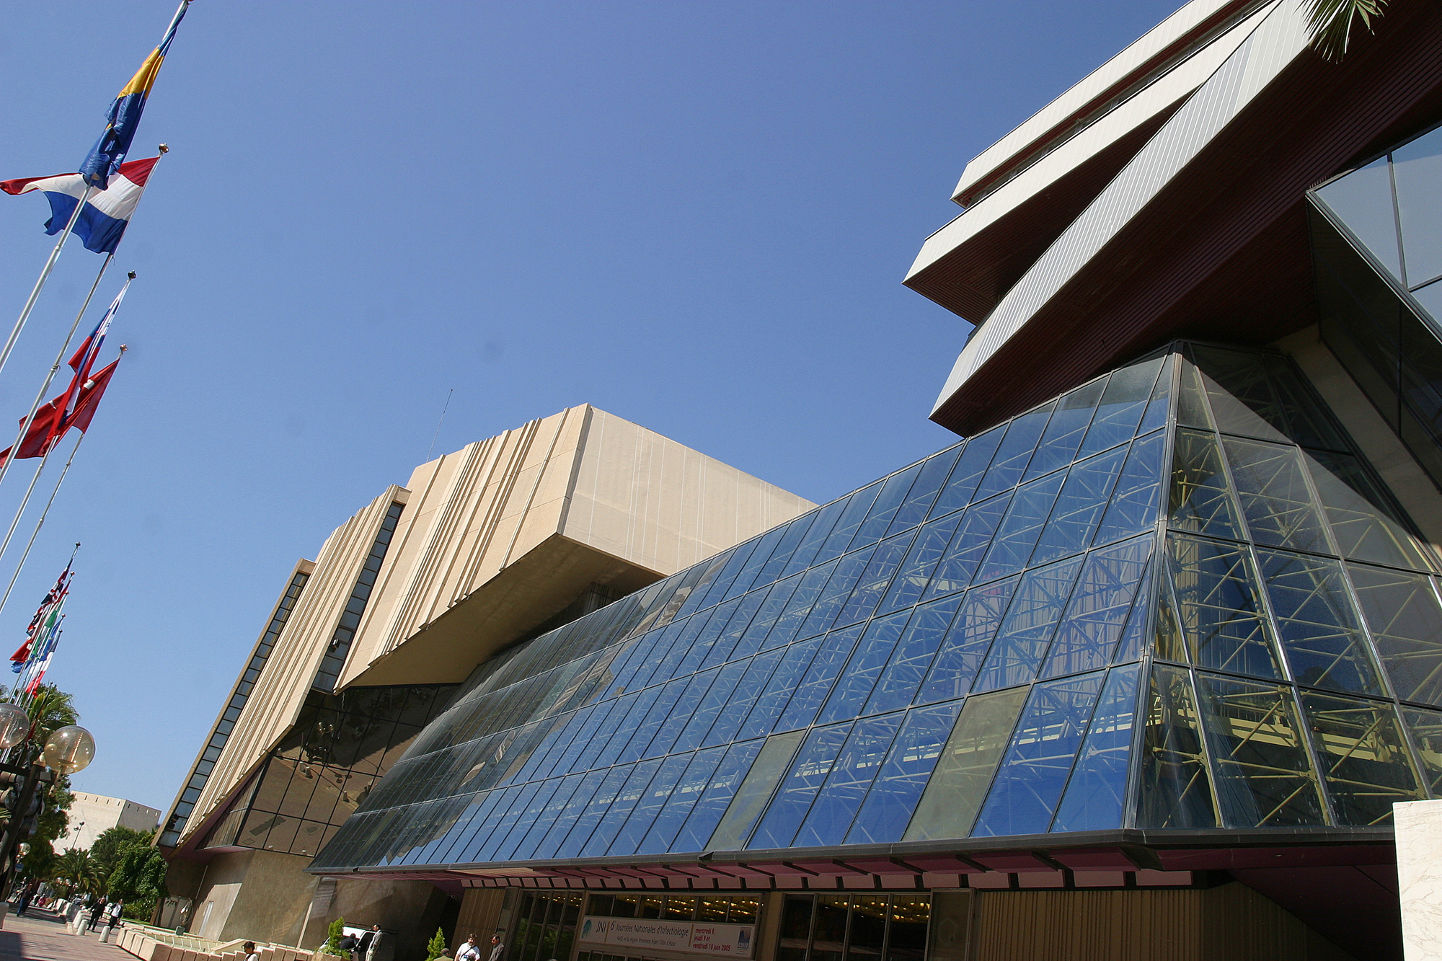

Fig. 1. Acropolis congress center of Nice where “Tritium2013” will be held. This is color example. However, please remind that all figures and photographs are printed in grey scale in the abstract.

